Undergraduate Research and Discovery Scholar Program

The Undergraduate Research and Discovery Program (URaD scholar program) is a one-year SoAS signature program that engages undergraduate students in research and/or artistic endeavors. The program sets up collaborations between research-active faculty and undergraduate students who undertake projects that engage with a topical issue.

Eligibility

The program is a selective and competitive program that is open to students who are enrolled in a program leading to an undergraduate degree.

Application Process
Interested students should apply online to the Office of the Dean by February 15 of their junior year and shall be notified of the status of their applications by April 1. Applications will be reviewed by a Committee chartered by the Dean and composed of a representative from each department. Participation is capped at 24 in the first year.

Applications Close: May 25, 2020 at 5:00 p.m.
Program Starts: June 15, 2020 for Four weeks.

Selection
This selective, competitive opportunity is open to students who are enrolled in a program leading to an undergraduate degree. Preference will be given to students who are already engaged in research with a research-active LAU faculty.

Discovery Curriculum
The Research and Discovery Scholar Program offers a series of three-hour workshops. Some will be required while others optional. Scholars need to complete the discovery curriculum in order to proceed to the next stage.
Core knowledge – Must be taken as a sequence
- Literature Search and Review [3 hours]. Literature review including search strategies, keeping up to date, organizing your material, reading a paper critically, organizing your material before writing, bibliographic annotation, integration and synthesis, and citation management and tools. Instructor: Dr G. Khazen
- Writing a Research Proposal [3 hours]. Learn how to write your research proposal including types of a research proposal, components: research problem, context, and results evaluation. Instructor: Dr J. Melki
- Effective Communication [6 hours]. Learn to be a better communicator by exploring the communication process and how different communication styles affect your personal style. Topics include empathy, asking the right questions, understanding the person’s viewpoint, and non-verbal communication. Instructors: Drs D. Badran and V. Khachan
- Capstone [One Week]. Students will work closely with a mentor in developing a research proposal to be pursued during the academic year 2020-2021 and presented at the SoAS Research Day.

SoAS iPark [Required]

- Innovation, Entrepreneurship, and Pitching your Idea [6 hours]. Overviews the key components in the innovation process and examples of major innovations. Customer service science and elevator pitching. The Language of Start-Ups including business language and terminology, business model, market study, impact, venture capitalists, funding rounds, and KPIs. Instructor: Dr M. Abboud
- Teamwork and Project Management [3 hours]. Organize your team’s work and manage projects from beginning to end: creating and assigning tasks, managing due dates, creating checklists, and project management tools. Instructor: Dr G. Khazen

STEAM [Required]

- Python Programming [6 hours]. Fundamentals of Python programming including data types, conditional statements, loops, and dictionaries. Applications to sciences and humanities will be discussed. Instructor: Dr H. Harmanani
- Introduction to Deep Learning for Computer Vision [6 hours]. A simple introduction to deep learning and artificial intelligence using NVIDIA online tools. Scholars will receive a certificate from NVIDIA Deep Learning Institute. Instructor: H. Harmanani
- Digital Humanities [3 hours]. Using digital data and technologies to answer humanities research questions. From text analysis to data visualization and more. Instructors: Drs C. Jenainati and H. Harmanani
- Research Methods in the Social Sciences and Humanities [6 hours]. Planning and designing research studies using appropriate research methodologies and data analysis techniques. Instructors: Drs C. Kozman and G. King
- Mapping the Self Through the Conflicted Landscape [3 hours]: Theories of space and place through an open process of landscape evaluation with a focus on affective and aesthetic relationship: visits of sites of historical conflict, street art, music, and film productions. Instructor: Dr C. Jenainati

Students will receive a certificate upon the completion of the Curriculum.

Projects
Participants work collaboratively to complete creative or scholarly outputs. Where projects are to be submitted for formal assessment as Capstone or Senior Projects, the student will be allocated a departmental advisor, and the submission will be individual.
Participants select one of 3 pathways of intellectual engagement :
- Mapping the Self Through the Conflicted Landscape

This pathways is multidisciplinary with a focus on cultural intelligence. Scholars are taught using Problem-Based Learning pedagogy and are expected to undertake active field research. Wiorking closely with the pathway lead, we reflect on theories of space and place through an open process of landscape evaluation: we document the landscape around us and we interpret its impact on the individual and collective sense of self through affective and aesthetic critique. The pathway includes visits of sites of historical conflict and examines street art, music, and film productions.
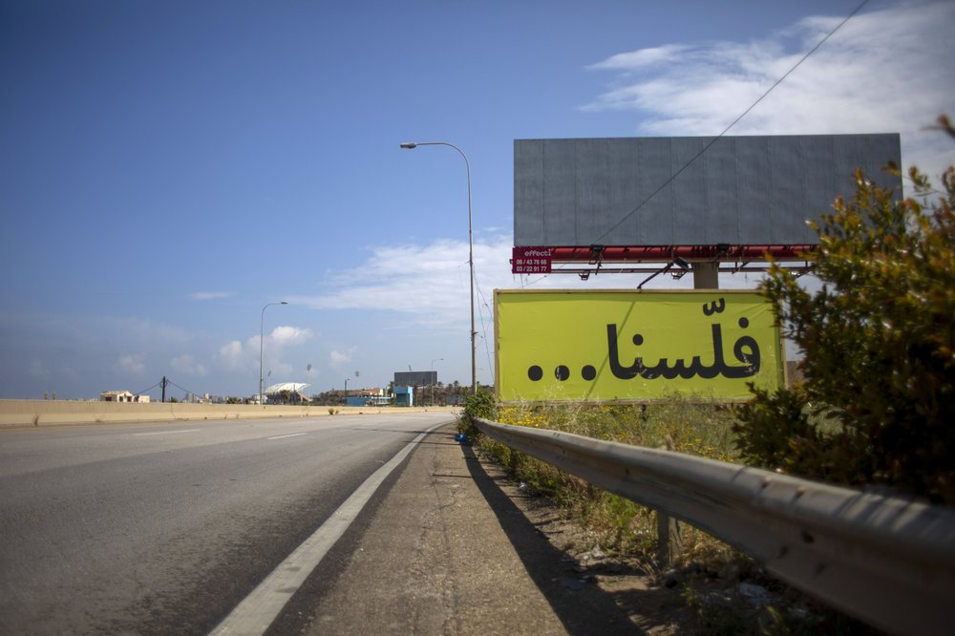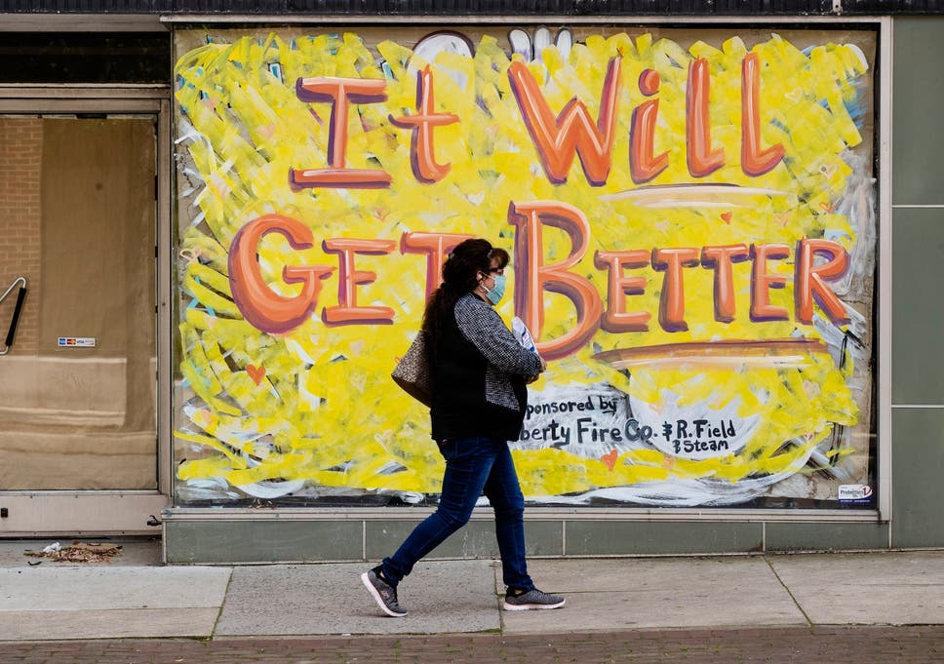
- SoAS iPark
This Pathway aims at unleashing the scholars’ creative potential by developing their creative skills, techniques, systems, and leadership behaviours. Scholars will be expected to pitch their own ideas and deliver an innovative product.
- SoAS STEAM
This Pathway focuses on developing scholars’ creative skills in Sciences, Technology, English, Arts, Digital Humanities, and Mathematics. Students will be mentored, and their research skills sharpened. The program will promote multidisciplinary projects leading to tangible research outputs such as publishing articles, proceedings, developing research-based theatre, and art exhibit, or a performance.

Faculty Involvement
Where relevant, scholars will be assigned a faculty mentor who shall oversee their effort. In addition to the Pathway Lead, the mentor shall guide the Scholar in writing and submitting a proposal, supervise his/her scholarly activity, and assist in the final report.

Deliverables
Students shall present their findings during the SoAS research day with the expectations of an article or proceedings submission, a publication, an innovative product, an art exhibit, or a performance.

Program will be defined at a later stage.

